What is power BI Report Server?
https://www.youtube.com/watch?v=q-_kVwOMgEk

it is an On premise report server with the web portal in which you display and manage the reports.
It allows you to create Paginated reports, Mobile reports , KPIs which users can access
The reports from this report server can be accessed through
Web browser
Mobile device
As an email attachment
This is very much similar to the SSRS report server
Why do we need it?
There are many companies that do not want to put their data in cloud services like AZURE, Google Cloud, AWS. In Such case, they want to maintain their data on premise to adopt this power bi report solutions.
Licensing Power BI Report Server
- Power BI Premium It is a dedicated capacity License. With this, you can create a hybrid deployment mixing Cloud and On Premise. To Publish the power BI Reports to the power BI report server, you need a power BI Pro License. If you just want to view and interact with power bi Reports in the report server, Pro License is not required.
- Sql server Enterprise Edition with SW Assurance By Paying a minimal additional cost, you can access Power BI Report server.

What is web portal?
It is a platform where the Power BI reports or Paginated reports are hosted/ published for users view. This web portal can be addressed through any modern web browser. Here you can access the following
Reports
KPIs
Content is grouped by Type, Power BI Reports, mobile reports, Paginated Reports, Excel Workbooks, Paginated Reports

What can you do in Web Portal?
You can manage the reports here
You can schedule the report processing here
You can subscribe to Published reports
You can also apply your own custom branding to your web portal
You can replace the Power BI Logo with the company logo

Pbix file can be developed with the power BI desktop optimized for the report server
There is a difference in the following report development
The reports we are developing for power BI Services
The reports we are developing for power BI report server
Both the above reports are developed using Power BI Desktop but for both we have different Power BI Application of power BI Desktop
For Power BI Report Server, we have an application called Power BI Desktop optimized for report Server. However, we have Power BI Desktop application for power BI report services

What are Paginated Reports?
These reports are a part of Power BI Premium Licence capability. It is a report with .RDL extension like SSRS reports.
These reports are document style reports with visualization in which tables expand horizontally and vertically
They are great for generating Report data for fixed layout, Pixel perfect document optimized for printing such as PDF and word Files.
It can be developed through report builder or report designer in Sql Server Data Tools

Reporting Services: Mobile Reports
Mobile reports connect to On premise Data and have respective layout that adapts to different devices
It can be created with SQL Server Mobile Report Publisher

Difference between Power BI Report Server and Power BI Service
Power BI Service
It is a cloud Service
Power BI Report Server
It is a hybrid combination of both Cloud and On premises. To access this, you need Power BI Premium License. In future, you can easily shift all your data to cloud

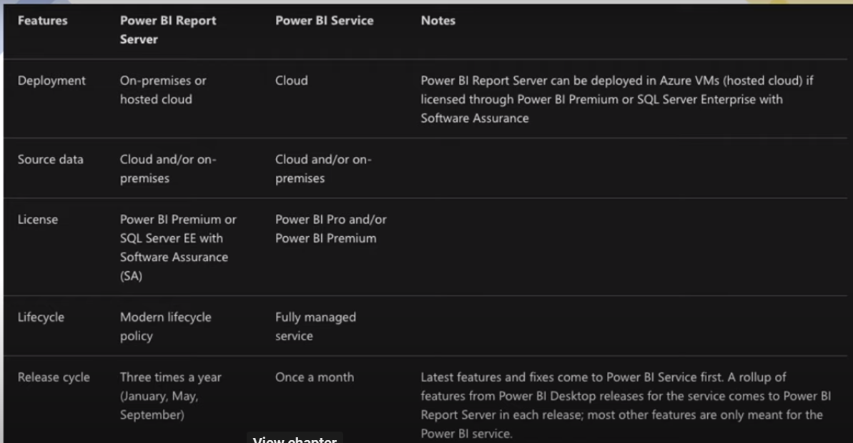

Common features between Power BI Report server and Power BI Service
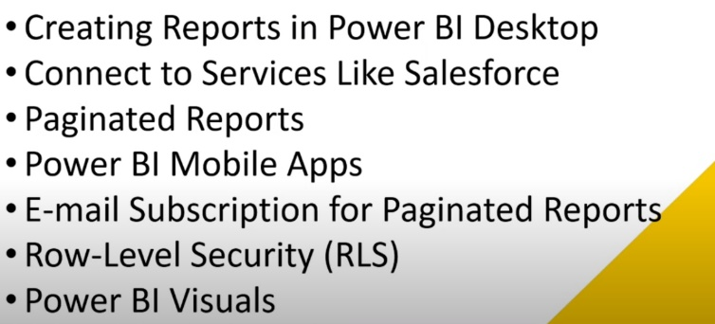

Missing Features in Power BI Report Server
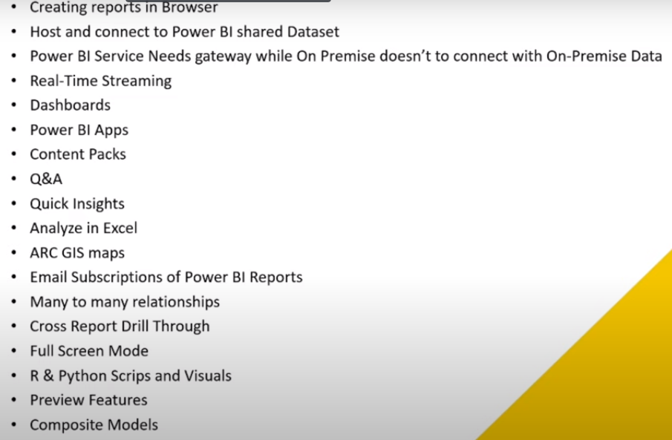

In General, How does a report server work?
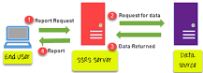
How SSRS Works? SSRS server finds the metadata of the report and sends a request for data to the data sources. Data returned by the data source is merged with the report definition into a report. When the report is generated, it is returned to the client.
How do I restart a report server?
Use Administrative Tools
- In Administrative Tools, open Services.
- Right-click SQL Server Reporting Services (MSSQLSERVER), SQL Server Reporting Services, or Power BI Report Server.
- Select Stop or Restart.

The Web Service URL page to configure or modify the URL used to access the Report Server.
The Web portal URL page to configure or modify the URL used to access Report Manager.
Web Service URL
Web Service URL is the backend, which is utilize by the frontend and also can be use from own application; see Report Server Web Service.
The web service URL is to access the SSRS Report Server. It is the URL where the reports get deployed to. You also get a raw report listing from this location if you enter it into your browser. When you deploy the reports from the tools such as report designer/report builder, you will need to use the backend web service URL.
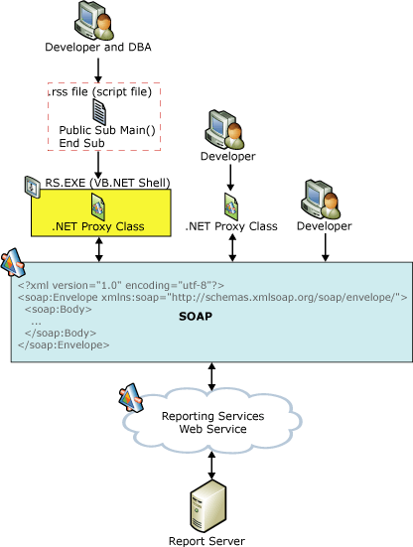
SQL Server Reporting Services provides access to the full functionality of the report server through the Report Server Web service. The Report Server Web service is an XML Web service with a SOAP API. It uses SOAP over HTTP and acts as a communications interface between client programs and the report server. The Web service provides two endpoints - one for report execution and one for report management - with methods that expose the functionality of the report server and enable you to create custom tools for any part of the report life cycle.
Web portal URL
Web Portal / Report Manager URL is the frontend to manage & Show reports; see Web portal (SSRS Native Mode).
The Web Portal URL is to access the Web Portal (Report Manager) It is a frontend web application which allows a user to view or administer reports in the reports server location. When you want to do the operations such as set user permissions, subscription, viewing and managing reports, you need to navigate to Web Portal URL.
Web portal (SSRS Native Mode).
The web portal of a Reporting Services report server is a web-based experience. In the portal, you can view reports, KPIs, and navigate through the elements in your report server instance. You can also use the web portal to administer a single report server instance.
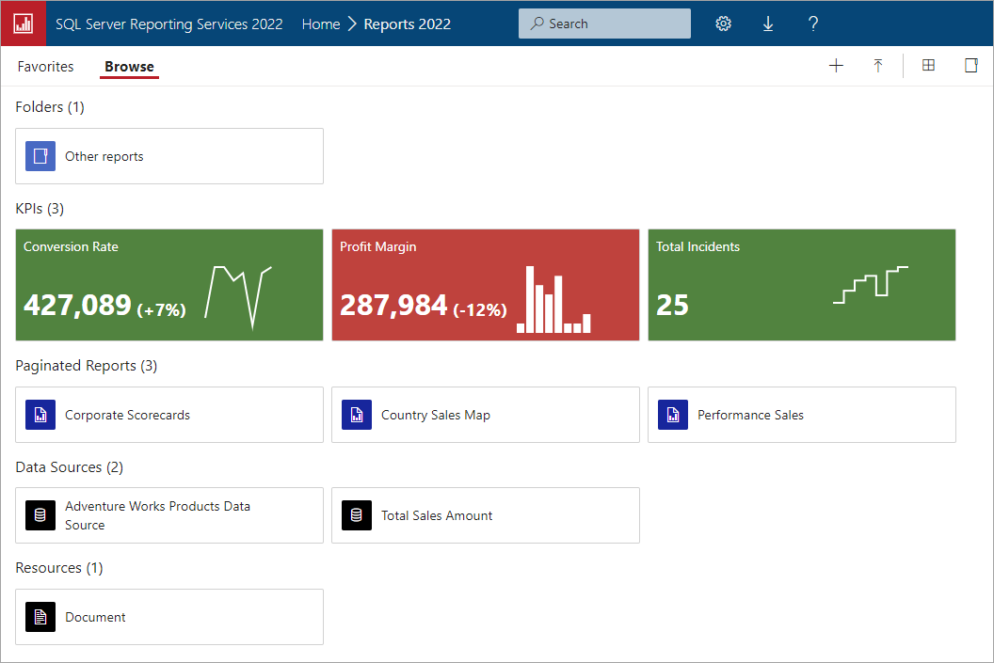
You can use the web portal to browse the report server folders or search for specific reports. You can view a report, its general properties and past copies of the report that are captured in report history. Depending on your permissions, you might also be able to subscribe to reports for delivery to an e-mail inbox or a shared folder on the file system.
The web portal is used only for a report server that runs in native mode. It is not supported for a report server that you configure for SharePoint integrated mode.
Some web portal features are only available in specified editions of SQL Server

